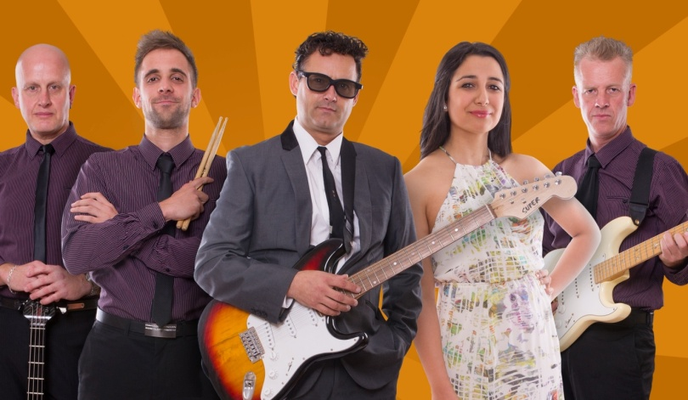

Act 5
This band delivered dynamic performances around Australia for welcoming and appreciative crowds. The range of venues is diverse and they are equally at home gigging for a hotel club gig, or at a festival, or in someone’s backyard.Whatever the audience or the location Pulse band delivers a magnificent performance.
Act 5 can also present a “Dinner with the Stars” theme show called The Desirables. Recently awarded 4 stars the Desirables show is a mixture of fine dining, dancing and Stars! Throughout the 4 hour entertainment programme there will be opportunities for you to mingle, dine, dance and even have your photograph with the Stars! Showcasing a magnificent blend of superb male and female vocals your ears will be humming with delight. The band line up delivers a dynamic and uplifting evening’s entertainment. Exciting costume changes are entwined with a fun story line guaranteed to keep you engaged and smiling from ear to ear.
Act 5 has performed at many major Festivals and Show Days including The Barossa Gourmet Weekend, Sea and Vines Festival, Clare Gourmet Weekend, Cape Jaffa Food and Wine Festival, Oysterfest, Barossa Vintage, Gawler Show, Lucindale Field Days and the Port MacDonnell Bayside Festival.
The band performs the best music from the 60s right through to current Top 40 Hits – music for every heart beat!

Song List
500 Miles – The Proclaimers
Achy Breaky Heart – Billy Ray Cyrus
Big Spender - Shirley Bassey
Billie Jean – Michael Jackson
Blame it on the Boogie - Jacksons
Blister in the Sun - Violent Femmes
Blue Suede Shoes – Elvis Presley
Boots Are Made For Walking – Nancy Sinatra
Brown Eyed Girl - Van Morrison
Bubbly - Colby Collait
Burning Love - Elvis
Call Me Maybe – Carly Rae Jepsen
Can’t Take My Eyes off of you - Lauren Hill
Cherry Cherry – Neil Diamond
Close To You – The Carpenters
Cocaine – Eric Clapton
Cold Shot - Stevie Ray Vaughan
Count on Me - Bruno Mars
Cracklin Rose – Neil Diamond
Crazy Little Thing Called Love - Queen
Crocodile Rock – Elton John
Dancing Queen – ABBA
Daydream Believer - Monkees
Disco Inferno - The Trammps
Dizzy – Tommy Roe
DJ Got us Falling in Love Again - Usher
Doo Wah Diddy – Manfred Man
Down Under - Men at Work
Drive My Car - Beatles
Eagle Rock - Daddy Cool
Eight Days A Week – Beatles
Fever - Peggy Lee
Finally - CeCePeniston
Get Lucky – Daft Punk
Get this Party Started - Pink
Gimme one reason - Tracey Chapman
Good Luck Charm - Elvis
Green Door – Shaking Stevens
Green Grass of Home - Tom Jones
Happy – Pharrell Williams
Heart Beat – Buddy Holly
Hey Good Looking – Hank Williams
Hey Soul Sister - Train
Hippy Hippy Shake – The Beatles
Holy Grail - Hunters & Collectors
Horses - Daryl Braithwaite
Hound Dog – Elvis
How Do You Do – Jerry & Pacemakers
I Feel Good – James Brown
I Heard It through The Grapevine – Marvyn Gaye
I’m a believer - The Monkees
I’m On My Way – The Proclaimers
I’m Yours - Jason Mraz
In the midnight hour - Wilson Picket
I Wanna Hold Your Hand - Beatles
I Will Survive - Gloria Gaynor
I Wish - Stevie Wonder
Jailhouse Rock – Elvis
Just the Way You Are - Bruno Mars
Kiss Me - Sixpence none the Richer
Knock on Wood - Eddie Floyd
Let’s Stick Together - Bryan Ferry
Let’s Twist Again – Chubby Checker
Land Down Under - Men at Work
Lazy Song - Bruno Mars
Le Freak - Chic
Let’s Twist Again – Chubby Checker
Locked Out Of Heaven – Bruno Mars
L.O.V.E. – Natalie Cole
Love Is In the Air - John Paul Young
Love Shack - B52’s
Mamma Mia – ABBA
Man I Feel Like A Woman – Christina Aguilira
Marry You - Bruno Mars
Mercy - Duffy
Miss You - Rolling Stones
Moondance - Van Morrison
Moves like Jagger - Maroon 5
Mustang Sally - Wilson Pickett
My Girl - The Temptations
Never Tear Us Apart – INXS
Nutbush - Tina Turner
Only Wanna Be With U – Dusty Springfield
Peggy Sue – Buddy Holly
Perfect – Fairground Attraction
Perhaps Perhaps Perhaps – Doris Day
Play that Funky music - Wild Cherry
Please Don’t Stop the Music – Rhianna
Pretty Woman – Roy Orbison
Price Tag – Jessie J
Proud Mary – Creedence
Raise Your Glass - PINK
Rave On – Buddy Holly
Rehab - Amy Whinehouse
Respect - Aretha Franklin
Rock Around the Clock - Bill Hayley
Rocking All Over the World – Status Quo
Saw Her Standing There - Beatles
Scar - Missy Higgins
Scar Tissue - RHCP
Sex Bomb - Tom Jones
Shake it Off – Taylor Swift
Shake Rattle n Roll - Bill Hayley
Shout – Lulu
Signed Sealed Delivered - Stevie Wonder
Simply The Best – Tina Turner
Smooth - Santana
Somethings Got A Hold on Me - Christina Aguilira
Son of a preacher man - Dusty Springfield
Soul Man - Sam & Dave
So What - Pink
Stand by me - Ben E King
Stuck in the Middle - Stealers Wheel
Sugar – The Archies
Superstition - Stevie Wonder
Sway - Bubble
Sweet about me– Gabrielle Cilmi
Sweet Caroline - Neil Diamond
Sweet Dreams - Eurythmics
Sweet Home Alabama - Lynard Skynard
The Tide Is High – Atomic Kitten
The Wanderer – Dion
Time of Your Life – Green Day
Treasure – Bruno Mars
True Love - Pink
Tutti Frutti – Little Richard
Twist n Shout - Beatles
UFO - Sneaky Sound System
Under The Bridge – RHCP
Uptown Funk – Bruno Mars
Valerie - Amy Whinehouse
Walking on Sunshine - Katrina & the Waves
Waterloo - ABBA
We Are Family - Sister Sledge
We Found Love - Rihanna
What I like about you - The Romantics
What's My Scene - Hoodoo Gurus
Wipeout - Instrumental
You’re The Devil In Disguise - Elvis
Your Love Keeps Lifting Me Higher – Jackie Wilson

Pulse Dinner Dance Songs

A Thousand Years – Christina Perri
Aint No Sunshine – Bill Withers
All I Have To Do Is Dream – Everly Brothers
All of Me – John Legend
All of Me – Sinatra
Amazed – Lonestar
At Last - Etta James
Ben – Michael Jackson
Blue Moon – The Marcels
Blue Spanish Eyes – Elvis Presley
Breaking Up Is Hard To Do – Neil Sedaka
Budapest – George Ezra
Can’t Help Falling In Love With You – Elvis
Come Away With Me - Nora Jones
Come Fly With Me – Frank Sinatra
Crazy – Patsy Cline
Don’t Know Why – Nora Jones
Don’t Worry Be Happy – Bobby McFerrin
Dream A Little Dream – Buble
Eternal Flame – The Bangles
Feel Like Making Love - Roberta Flack
Fly Me to the Moon – Sinatra
Girl from Ipanema - Astrud Gilberto
Give me the Night - George Benson
Hallelujah - Leonard Cohen/Jeff Buckley/KD Lang
Have I Told You Lately – Van Morrison
Heaven – DJ Sammy
Home – Buble
How Sweet it is - Marvyn Gaye
If I Ain’t Got You - Alicia Keys
I Got You Under My Skin – Frank Sinatra
I Have Nothing - Whitney Houston
I Just Called To Say I Love You - Stevie Wonder
It Had To Be You – Frank Sinatra
It’s Not Unusual – Tom Jones
Just the Two of Us - Bill Withers
Let’s stay together - Al Green
Living Doll – Cliff Richard
Love Me tender – Elvis
Lovely Day – Billy Withers
Make You Feel My Love – Adele
Marry You – Bruno Mars
My Baby Just Cares For Me – Norah Jones
New York New York - Sinatra
Return To Sender – Elvis Presley
Right as Rain - Adele
Save the last dance for me – Frank Sinatra
Saving all my love - Whitney Houston
Sign Your Name – Sheryl Crowe
Sitting on the Dock of the Bay - Otis Redding
Someone Like You – Adele
Somewhere Over The Rainbow – Eva Cassidy
Something Stupid – Robbie Williams & Nicole Kidman
Songbird – Eva Cassidy
Song Song Blue – Neil Diamond
Summer Holiday – Cliff Richard
Summertime – Ella Fitzgerald
Teddy Bear – Elvis
Tequila Sunrise – Eagles
The Prayer – Bocelli
Thinking Out Loud – Ed Sheeran
Under The Boardwalk - Drifters
Unforgetable – Nat King Cole
Way Out West – The Dingoes
What A Wonderful World – Louis Armstrong
When You Say Nothing At All – Ronan Keating
Will You Still Love Me Tomorrow - Amy Whinehouse
You Are the Sunshine of my life - Stevie Wonder
You Send Me – Sam Cook

Pulse Songs Sung In Italian

Anema e Core - GigliolaCinquetti
Il Mondo - PatrizioBuanne
FuniculiFunicula - Mario Lanza
Lazy Mary (Ce La Luna Mezzo Mare) - Lou Monte
Mambo Italiano - PatrizioBuanne
Marina MarinaMarina – Rocco Granata
Piccolissima serenata – Renato Carosone
Quando, Quando, Quando - Engelbert Humperdinck
Rose Rosse Per Te – Massimo Ranieri
That's Amore - Dean Martin
The Chicken Dance – Various
Ti Amo - PatrizioBuanne
Un Angelo (Angels) - PatrizioBuanne
Volare - Dean Martin
You're My World - PatrizioBuanne

