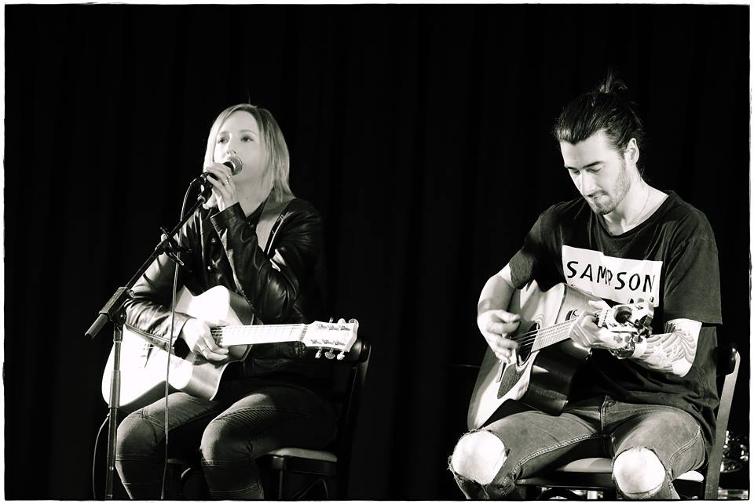

Revive
Acoustic Duo

Song List
Linger / Cranberries Imagine / Jon Lenon
Save Tonight / Eagle Eye Cherry Crying Shame / Diesel
Sweet Child of Mine / Guns n Roses Sweet about Me / Gabriella Chilmy
Big Jet Plane / Angus N Julia Stone Higher and Higher / Jimmy Barnes
Walking on Sunshine / Katrina and the Waves Wish You Well / Bernard Fanning
When You Say Nothing At All / Ronan Keating Use Somebody / Kings of Leon
Marry Me / Bruno Mars Drops Of Jupiter / Train
Not Pretty Enough / Kasey Chambers Let It Be / Beatles
Dreams / Fleetwood Mac Break Even / The Script
The A Team / Ed Sheeran Zombie / The Cranberries
Don’t Stop / Fleetwood Mac Lover Lover / Sonja DaDa
Luka / Suzanne Vega Head over Feet / Alanis Morissette
Perfect / Fairground Attraction Pony / Kasey Chambers
Run Around Sue / Dion and The Belmont’s Hero / Enrique Igesias
Lean on Me / Bill Withers I’m Yours / Jason Maraz
Goodbye My lover / James Blunt Kiss Me / Sixpence None The Richer
Sweet Home Alabama / Lyned Skyned Buses and Trains / Bachelor Girl
No Rain / Blind Melon Bleeding Love / Leona Lewis
Brown Eyed Girl / Van Morrison Someone like You / Adele
The First Cut is The Deepest / Cheryl Crowe Leave Me Alone I’m Lonely / Pink
Knocking On Heavens Door / Bob Dylan Stumbling In / Suzi Quatro
Falling In Love Again / Eagle Eye Cherry Stand By Me / John Lennon
Pumped Up Kicks / Foster the People Pleasure and Pain / The Divinyls
Proud Mary / Creedence Clearwater Revival My Happiness / Powder finger
Mustang Sally / The Commitments Scar / Missy Higgins
All About the Bass / Meghan Trainer Sex on Fire / Kings of Leon
Have You Ever Seen The Rain / Creedence
Still Haven’t Found What I’m Looking For / U2

Reference

I would highly recommend Lyndsie as entertainment for any function.
The list of songs offered for each set played suited us and her voice was perfect for our wedding.
It suited the ambiance and it was a pleasure listening to her whilst we were sitting down to eat.
Thanks for a great wedding day/night Lyndsie ☺

Kind Regards,
Kellie Morgan

